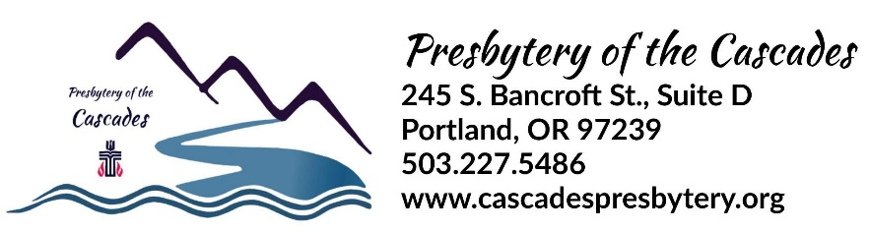
SUPPLY PASTOR COVENANT

The following covenant between the session of |  | Type Congregation Name Here | Presbyterian Church and
The Rev. | Type Pastor’s Name Here
is for the purpose of defining the terms of the Supply Pastor Position.

from | mm/dd/yy | to | mm/dd/yy
This covenant is for dates:

The Supply Pastor (check the appropriate response):
☐ Will become ☐ Is a member of the Presbytery of the Cascades.
☐ Will ☐ Will not serve as moderator of session.
☐ Will ☐ Will not serve as head of staff.

The Position Description for this position is attached to this covenant.

The goals for this relationship, approved by session and the Commission on Ministry are as follows:

Annual Review: The session and the presbytery COM will conduct a review with the pastor each year before considering renewal of the covenant. Goals and terms may be revised at that time. Renewal of the covenant requires approval by the Commission on Ministry.

Pastoral Search: If the church, with COM concurrence, begins a search for a new pastor, the Stated Supply Pastor becomes Interim Pastor, may not be considered as a prospective candidate and may not be involved in the pastor nominating process.

This covenant is for a period of up to 12 months (not more than twelve, G-2.0504b). This covenant may be terminated by the session with 30 days written notice. The Stated Supply Pastor may terminate the covenant with 30 days written notice and a forfeiture of any payment beyond the 30 day period.

Terms:
The Supply Pastor is employed on a ☐ full-time ☐ part time (50%, 75%, etc.) basis, serving
approximately | # of hours | hours per week. Compensation, to be reviewed annually, will be:

Salary | $ | Housing | $
Utilities | $ | Social Security Allowance | $
Professional Expense | $ | Vacation | Four Weeks
Continuing Education | $ | Study Leave | Two Weeks
Other | $ | Other | $

Board of Pensions (check which apply): ☐ Medical ☐ Retirement

Signatures (Either digital or written signature is acceptable):

Supply Pastor

Clerk of Session

Date of Session Action: Click or tap to enter a date.

Approved by Commission on Ministry:
Region:
Date: | Click or tap to enter a date.

Information only:
As approved at the summer online Stated Meeting held on June 11-12, 2021, the presbytery MINIMUM TERMS OF CALL for Ministers, Commissioned Ruling Elders, and Certified Christian Educators for 2022 shall be:

$51,827 in Compensation (Includes Salary, Housing Allowance/Manse Value,
403B Contributions, SECA allowance, etc.)
$1,500 in Continuing Education
$3,500 in Professional Expenses (including Travel Allowance)
4 Weeks of Vacation
2 Weeks of Continuing Education
3 Month sabbatical at full pay after each six (6) years of service.
Full coverage through the Board of Pensions for medical and retirement benefits.

Additionally for 2022, the recommended Cost of Living Adjustment for all Ministers, Commissioned Ruling Elders and Certified Christian Educators currently serving congregations is 3.9% above their existing compensation.

