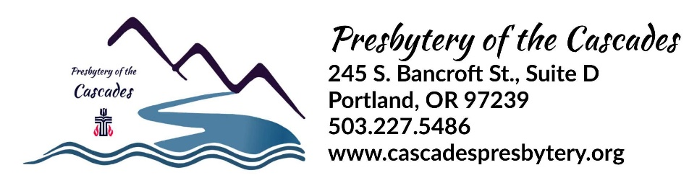
COMMISSIONED RULING ELDER (CRE) COVENANT

The following covenant between the session of |  |  | Church Name | Presbyterian Church of
Church City |  | and
Elder | Name
is is for the purpose of defining the terms of the Commissioned Ruling Elder (CRE) position.

The Position Description for this position is attached to this covenant.
List key goals for this relationship as approved by the Session and COM:
1.) Provide spiritual leadership through Sunday worship, preaching and administration of Sacraments.
2.)Provide pastoral care by visiting the sick and consoling the bereaved. Officiate at funerals, memorials & weddings.
3.)Moderate session and congregational meetings which will include assisting the congregation in discerning ECPC’s future
4.)
5.) (use more space as needed)

This covenant is for a period of up to |  | months (not more than 3 years G-2.1001).
- This agreement may be ended by the session upon 30 days written notice. The Commissioned Ruling Elder may end the agreement with 30 days written notice and a forfeiture of any payment beyond the 30 day period.

Terms to be reviewed annually are:
The CRE is employed on a ☐ full-time ☐ part time (50%, 75%, etc.) basis, serving
approximately | ? hours | hours per week.

Salary | $ | Housing | $
Utilities | $ | Social Security Allowance | $
Professional Expense | $ | Vacation | Four Weeks
Continuing Education | $ | Study Leave | Two Weeks
Other | $ | Other | $
Full pension, medical, disability and death coverage under the Board of Pensions.
Attendance at the ☐Spring ☐ Fall presbytery Discovery Retreat.

Signatures (Either digital or written signature is acceptable):

Commissioned Ruling Elder

Clerk of Session

Date of Session Action: Click or tap to enter a date.

Commission on Ministry Chair

Approved by Commission on Ministry:
Region:
Date: | Click or tap to enter a date.

In accordance with G-2.1001, the Commission on Ministry on behalf of Cascades Presbytery authorizes that the Commissioned Ruling Elder

    - May May Not Moderate the session of the congregation to which he/she is commissioned.
    - May May Not Administer the Sacrament.
    - May May Not Officiate at marriages where permitted by state law.
    - May May Not Have a voice and vote in meetings of presbytery (such vote to be counted as a
Ruling Elder Commissioner for purposes of parity).

