Pioneer Presbyterian Church
Warrenton, OR
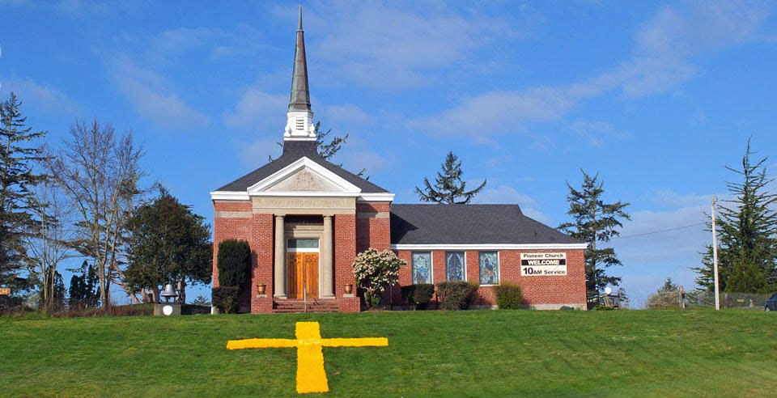

Mission Statement of Pioneer Presbyterian Church
Respecting the tradition of the Pioneers of our Faith, we worship the Word of God and honor the sacrifice of Jesus Christ. Our duty then is to help those in need, pray for those hurting, and rejoice in the love and blessings of God.

Position: Supply Pastor ¾ Time (30 hours/week)

Purpose: To fill the role of pastor with genuine religious commitment and contagious care and effort toward building our sense of Christian community. To lead the Session and congregation through the process of identifying needs, mission and vision of our church in the larger community.
Accountability: To the Pioneer Church Session and Cascades Presbytery.

Skills Required:
- An ability to relate to other people honestly and warmly with an enthusiastic commitment to Jesus Christ.
- Dedication to and skills in preaching and leading worship.
- Experience in assisting congregations in identifying and articulating mission and goals.
- Good organizational skills.
- Interest and experience leading Sunday worship services on a weekly basis.

Responsibilities:

- Lead Sunday worship services, including serving the sacraments of the Presbyterian Church (USA), and provide opportunities for Christian education.
- Conduct weddings, funerals, ordinations, installations, and dedications.
- Moderate Session meetings and assist the ruling elders and congregation in the process of identifying congregational identity and mission.
- Advise and encourage the Deacons and various church committees.
- Serve as head of church staff.
- Be available to members of the congregation with consistent office hours.
- Affirm and facilitate the local congregation's affiliation with Presbytery.
- Develop communications and relationships with other Christian communities active on the North Coast.

Application:

To apply, or find out more about the congregation, please contact Jim Kapellen at jctbr@pacifier.com or (503) 325-7548.

Further Information:
Pioneer Presbyterian Church was established in 1846 and is the oldest continuous worshiping Presbyterian church west of the Rockies. With a capacity of 70 people and facilities for social gatherings, it has a secure and relaxed atmosphere. The congregation currently consists of 30 members and fluctuates with the seasons. The church has a website and live streams its Sunday service on You tube. This is starting to attract a small international following.

Pioneer Presbyterian Church resides in Clatsop County, in the northwest corner of Oregon, bounded by the Columbia River to the north and the Pacific Ocean to the west. Located on highway 101, midway between Astoria, Oregon’s oldest city, and Seaside, one of Oregon’s most popular beach towns, the Pioneer Presbyterian church is perfectly situated to experience both the beauty of nature and the closeness of a wonderful community. It is also just about 75 miles northwest of Portland and the Portland International Airport.

The church itself sits on 6 acres on the Clatsop Plains south of Warrenton, Oregon, on a gently rolling hillside adjacent to the Lewis and Clark trail and the historic Pioneer Cemetery. The modest brick building is an inviting sight in an inspirational setting. It is famous for its 32-foot cross, made entirely of daffodils, laid out on the hillside in the front of the church. Over 30,000 daffodils blossoms are picked and placed by church and community members each Easter.

Ocean Beaches, dense rainforest, mountains, lakes, streams and one of the largest rivers in America, provide endless opportunities for almost any outdoor activity. Razor clamming here is some of the best in the world. Plant and animal species abound. Whales and seals migrate along the coast. Herds of elk and deer inhabit the entire county. Bird varieties are numerous, including Bald Eagles and Osprey.

Area Services, facilities, and attractions
Clatsop County Oregon (population 37,300) - https://www.co.clatsop.or.us

Medical:
Columbia Memorial Hospital - columbiamemorial.org Providence Seaside Hospital - oregon.providence.org
US Coast Guard - www.pacificarea.uscg.mil/

Education:
Astoria High School - www.astoria.k12.or.us
Seaside High School - www.seaside.k12.or.us
Clatsop Community College - clatsopcc.edu
Warrenton High School - www.warrentonschools.com

Cultural Attractions:
Clatsop County is home to 7 museums, 4 historical societies and more than 40 galleries.
Fort Stevens State Park - stateparks.oregon.gov
Columbia River Maritime Museum - crmm.org
Astoria Column - astoriacolumn.org
Haystack Rock - cannonbeach.org

