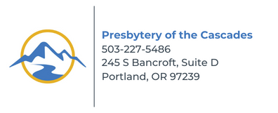

2026 PER CAPITA and PRESBYTERIAN PARTNERSHIP GIVING PLEDGE FORM

Clerk or Treasurer: please complete and return by January 31, 2026

2026 Per Capita – At the October 25, 2025, Stated Meeting of the Presbytery, ministers and commissioners from congregations voted to set Presbytery per capita at $50.00. For 2026, per capita is calculated on your church’s 2024 membership.

The per capita apportionment for each member is $50.00 and shared:

The General Assembly $10.84
The Synod Of The Pacific $ 5.22
The Presbytery of the Cascades $33.94
TOTAL $50.00 Per Capita / Member for 2024

Presbyterian Partnership Giving Pledge — Basic Mission Support/Undesignated Giving which provides direct support of our mission congregation, Warm Springs PC, as well as supporting services and missions of the Presbytery (including New Worshipping Communities), and mission support to our Synod and General Assembly not covered by per capita. Amount is determined by the Session.
Goal: Per Capita + Partnership Giving = 10% of congregation’s operating budget.

Church:

City:

2024 Membership: 19 Members X $50.00 = $

Partnership Giving Pledge determined by the session: $_______________

= = = = C U T H E R E A N D R E T U R N T H I S P O R T I O N T O T H E P R E S B Y T E R Y O F F I C E = = = =

Church:

City:

___ Enclosed you will find the full remittance of our 2026 per capita.
--OR--
___ We will pay our 2026 per capita in full by January 31, 2026.
--OR--
___ We will pay by installments and in full by September 30, 2026.

We also pledge $__________________ in Presbyterian Partnership Giving for 2026.

Other/Notes:____________________________________________________________________________

Thank you for your generosity and timely support to help us remain the connectional church!

